System Requirements Specification (SRS)
Change Management, Incident Management, Ticketing System and IT Service Integration
Document ID | ITSM-SRS-001
Version | 1.0
Status | Draft for Review and Approval
System Type | Unified IT Service Management Platform
Deployment Model | Cloud, On-Premises and Hybrid
Standards Alignment | ITIL-aligned service management, ISO 27001, PCI DSS where applicable

1. Purpose
The purpose of this document is to define the functional, technical, operational, security, and integration requirements for a centralized IT Service Management (ITSM) platform.
The platform shall provide a unified system for managing IT incidents, planned and emergency changes, service requests, tickets, configuration items, service dependencies, approvals, service-level agreements, and operational reporting.
The solution shall integrate with infrastructure monitoring, security monitoring, asset management, identity management, and governance, risk, and compliance (GRC) systems.
The objective is to improve service availability, reduce incident resolution time, control changes to production environments, strengthen accountability, and provide auditable evidence of IT operations.

2. Objectives
The system shall:
- Centralize incident, change, and service request management.
- Provide a common ticketing interface for IT support teams and authorized business users.
- Automate incident creation from monitoring and security alerts.
- Establish controlled, risk-based change approval and implementation workflows.
- Link incidents and changes to affected IT services, assets, configuration items, and business owners.
- Enforce priority, escalation, approval, and SLA policies.
- Maintain complete audit trails for ticket activities, approvals, and configuration changes.
- Integrate with CMDB, monitoring, identity, notification, and GRC systems.
- Support cloud, on-premises, and hybrid deployment architectures.
- Support ITIL-aligned service management and relevant information security and compliance requirements.

3. Scope

3.1 In Scope
- Incident Management
- Change Enablement / Change Management
- Centralized ticketing
- Service Request Management
- Service catalog and service ownership
- SLA and escalation management
- Configuration Management Database (CMDB) integration
- Monitoring and event integration
- Security incident integration
- Approval workflows
- Knowledge management
- Reporting and dashboards
- Audit logs and compliance evidence
- Identity and access management
- Email and notification integration
- Cloud and on-premises infrastructure support

3.2 Out of Scope for the Initial Implementation
Unless separately approved, the following shall be treated as future enhancements:
- Full Security Operations Center (SOC) case management
- Automated remediation of high-risk production changes
- Complete financial management and IT cost allocation
- Full enterprise GRC replacement
- Automated PCI DSS certification or ISO 27001 certification
- Full software development lifecycle management

3.3 Logical Architecture Overview
Users raise and track tickets through the portal, email, or APIs. The platform receives events from monitoring and security tools on the left, and exchanges data with the CMDB, identity provider, notification channels, and GRC system on the right. Each module label points to the requirement group that defines it.
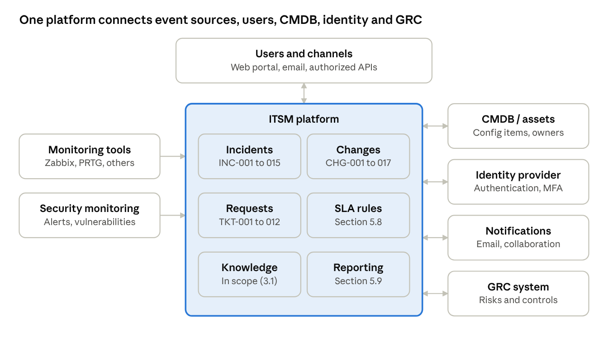
logical architecture · platform, users, event sources and integrations

4. User Roles and Responsibilities
Role | Responsibilities
4.1 Requester | Create incidents, service requests, and change requests where authorized. Provide accurate descriptions, business impact, and supporting evidence. Track ticket status and communicate with the assigned team.
4.2 Service Desk Agent | Register, classify, categorize, and prioritize incidents. Perform initial diagnosis and troubleshooting. Assign tickets to the appropriate support group. Monitor SLA compliance and communicate progress.
4.3 Incident Manager | Coordinate major incidents. Manage escalation, stakeholder communications, and recovery activities. Ensure incident records and post-incident reviews are completed.
4.4 Change Requester | Submit change requests with justification, scope, risk, implementation plan, and rollback plan. Attach required technical and business documentation.
4.5 Change Manager | Validate change requests for completeness. Coordinate risk assessment and approval. Manage the change calendar and change conflicts. Ensure changes are reviewed and closed correctly.
4.6 Change Approver / CAB | Review changes according to risk, impact, and organizational policy. Approve, reject, or request additional information. Ensure appropriate separation of duties.
4.7 Change Implementer | Implement only authorized changes. Record implementation evidence, results, and deviations. Execute the rollback plan when required.
4.8 Service Owner / Configuration Manager | Maintain service ownership, service dependencies, and configuration records. Assess business impact and validate affected assets.
4.9 System Administrator / Security Administrator | Configure workflows, roles, integrations, retention policies, and system security. Maintain system availability and monitor integration health.
4.10 Auditor / Compliance Officer | Access authorized records, approvals, evidence, audit trails, and compliance reports. Review control effectiveness and corrective actions.

5. Functional Requirements
Requirement priority is classified as follows:
Code | Priority | Meaning
M | Mandatory | Required for production acceptance.
S | Should have | Important capability that may be phased.
C | Could have | Optional enhancement.

5.1 Incident Management
ID | Requirement | Priority
INC-001 | The system shall allow authorized users to create incidents through a web portal. | M
INC-002 | The system shall accept incidents created by email integration, monitoring alerts, and authorized APIs. | M
INC-003 | Each incident shall receive a unique, system-generated incident ID. | M
INC-004 | The system shall support incident categorization, subcategorization, service association, and assignment groups. | M
INC-005 | The system shall calculate priority based on configured impact and urgency rules. | M
INC-006 | The system shall support configurable incident states, including New, Assigned, In Progress, Pending, Resolved, and Closed. | M
INC-007 | The system shall support assignment, reassignment, escalation, and transfer between support teams. | M
INC-008 | The system shall calculate SLA deadlines and issue alerts for approaching or breached SLAs. | M
INC-009 | The system shall support major incident identification and coordinated response. | M
INC-010 | The system shall record investigation notes, actions, timestamps, resolution details, and supporting attachments. | M
INC-011 | The system shall link incidents to affected services, configuration items, related changes, and problem records. | M
INC-012 | The system shall support user notifications for assignment, status changes, escalation, resolution, and closure. | M
INC-013 | The system shall support incident reopening under a configurable policy. | M
INC-014 | The system shall support root-cause and post-incident review records for qualifying incidents. | S
INC-015 | The system shall identify recurring incidents and allow them to be linked to problem records. | S

5.2 Incident Lifecycle
The default incident workflow shall be:
New → Categorized → Prioritized → Assigned → In Progress → Resolved → Closed
Additional states may include Pending User, Pending Supplier, Pending Change, and Escalated.
The workflow shall enforce the following controls:
- A new incident must have a description, requester or originating system, and creation timestamp.
- Priority shall be calculated or assigned according to approved rules.
- Assignment and escalation shall be recorded in the ticket history.
- Resolved incidents shall include resolution details and a resolution timestamp.
- Closure shall follow the organization's verification and closure policy.
- Reopened incidents shall retain their original history and reference.

5.3 Change Management
ID | Requirement | Priority
CHG-001 | The system shall support Standard, Normal, and Emergency change types. | M
CHG-002 | Standard changes shall use pre-authorized models with documented eligibility and controls. | M
CHG-003 | Normal changes shall undergo documented risk assessment and required approvals before implementation. | M
CHG-004 | Emergency changes shall follow an expedited, controlled authorization and retrospective review process. | M
CHG-005 | Every change shall receive a unique change request ID. | M
CHG-006 | The system shall capture change description, justification, scope, affected services, assets, and business impact. | M
CHG-007 | The system shall require implementation steps, testing procedures, validation criteria, and rollback plans according to change risk. | M
CHG-008 | The system shall support risk scoring based on impact, likelihood, complexity, criticality, and recovery considerations. | M
CHG-009 | The system shall support configurable approval chains based on change type, risk, service, and environment. | M
CHG-010 | The system shall support Change Advisory Board (CAB) review and meeting records where required. | S
CHG-011 | The system shall provide a change calendar and detect scheduling conflicts. | M
CHG-012 | The system shall associate changes with related incidents, problems, assets, and services. | M
CHG-013 | The system shall record implementation status, actual start and end times, results, and deviations. | M
CHG-014 | The system shall support failed change handling, rollback records, and incident creation or linkage. | M
CHG-015 | The system shall require post-implementation review for failed, emergency, and other designated high-risk changes. | M
CHG-016 | The system shall retain a complete history of change approvals and modifications. | M
CHG-017 | The system shall support change success-rate, failure-rate, emergency-change, and unauthorized-change reporting. | M

5.4 Change Lifecycle
The standard change workflow shall be:
Draft → Submitted → Validation → Risk Assessment → Approval → Scheduled → Authorized for Implementation → Implemented → Validation → Post-Implementation Review → Closed
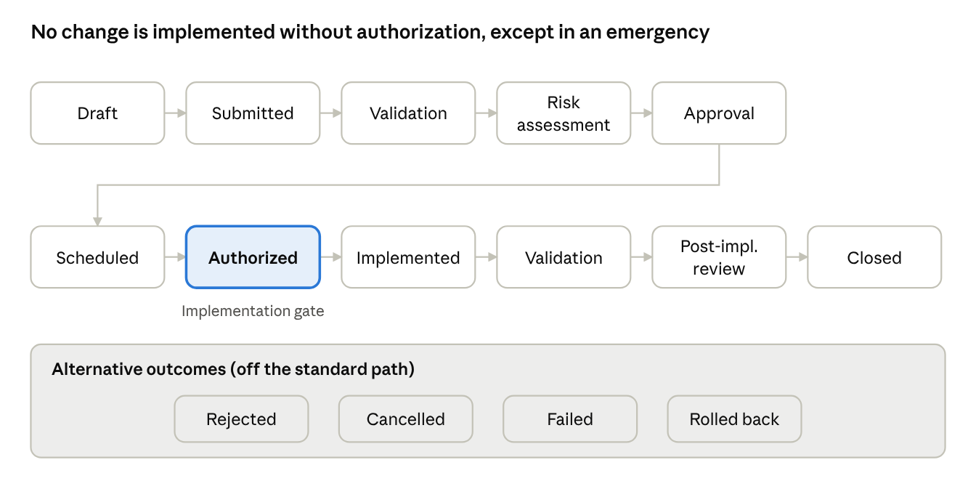
change lifecycle · 11 stages, 4 alternative outcomes
Authorization is the gate: only the formally defined emergency procedure may bypass it. Rejected, Cancelled, Failed, and Rolled Back sit outside the standard path.
Alternative outcomes shall include Rejected, Cancelled, Failed, and Rolled Back.
Controls:
- Changes shall not enter the implementation stage without the required authorization, except under a formally defined emergency procedure.
- Approval requirements shall be based on the approved change model and risk policy.
- The requester, approver, and implementer roles shall be separated for high-risk changes where practicable.
- Emergency changes shall record the reason for urgency, authorization, implementation evidence, and retrospective review.
- Changes affecting critical services or regulated environments shall trigger additional approvals when required.
- Unauthorized changes shall be recorded, investigated, and escalated according to security policy.

5.5 Ticketing and Service Request Management
ID | Requirement | Priority
TKT-001 | The system shall provide a centralized ticket repository. | M
TKT-002 | The system shall support incidents, service requests, change requests, and problem records as distinct record types. | M
TKT-003 | Tickets shall have unique IDs, status, category, priority, owner, assignment group, and timestamps. | M
TKT-004 | The system shall support attachments, comments, internal notes, and controlled user communications. | M
TKT-005 | The system shall provide ticket search, filtering, sorting, and saved views. | M
TKT-006 | The system shall support configurable ticket forms and mandatory fields. | M
TKT-007 | The system shall support related, parent-child, duplicate, and linked tickets. | M
TKT-008 | The system shall support configurable assignment rules and escalation policies. | M
TKT-009 | The system shall maintain a timestamped history of status changes, assignments, approvals, and relevant edits. | M
TKT-010 | The system shall provide requester-facing status tracking and authorized service desk views. | M
TKT-011 | The system shall support service request catalog items and approval workflows. | S
TKT-012 | The system shall support customer satisfaction feedback and service quality reporting. | S

5.6 Service Integration and CMDB
ID | Requirement | Priority
INT-001 | The system shall integrate with the selected monitoring platform using documented APIs, webhooks, or supported connectors. | M
INT-002 | Monitoring events shall create or update incidents based on configurable event rules. | M
INT-003 | The integration shall support event deduplication and correlation to minimize duplicate tickets. | M
INT-004 | Tickets shall be associated with affected business services and configuration items when information is available. | M
INT-005 | The system shall integrate with an asset inventory or CMDB to retrieve configuration details and ownership. | M
INT-006 | The system shall support integration with identity providers and directory services for user provisioning and authentication. | M
INT-007 | The system shall support email notifications and, where approved, collaboration or messaging integrations. | M
INT-008 | The system shall provide documented APIs for creating, updating, querying, and linking supported records. | M
INT-009 | Integration failures shall be logged, monitored, and retried according to a defined policy. | M
INT-010 | The system shall protect integration credentials using approved secrets management practices. | M
INT-011 | The system shall link qualifying security incidents and corrective actions to relevant risk and control records in the GRC system. | S
INT-012 | The system shall support reconciliation of integration records and report failed or incomplete synchronization. | M

5.7 Monitoring and Event Integration
The system shall support integration with the selected monitoring tools, such as Zabbix, PRTG, or other approved products.
The integration shall:
- Receive availability, performance, infrastructure, and application alerts.
- Map event severity to incident priority using configurable rules.
- Include the source device, monitored service, event time, and event identifier.
- Update or resolve the corresponding incident when the source event recovers, subject to workflow rules.
- Suppress duplicate events and group related alerts where appropriate.
- Avoid automatically closing an incident that requires human investigation or verification.
- Maintain traceability between monitoring events and associated tickets.
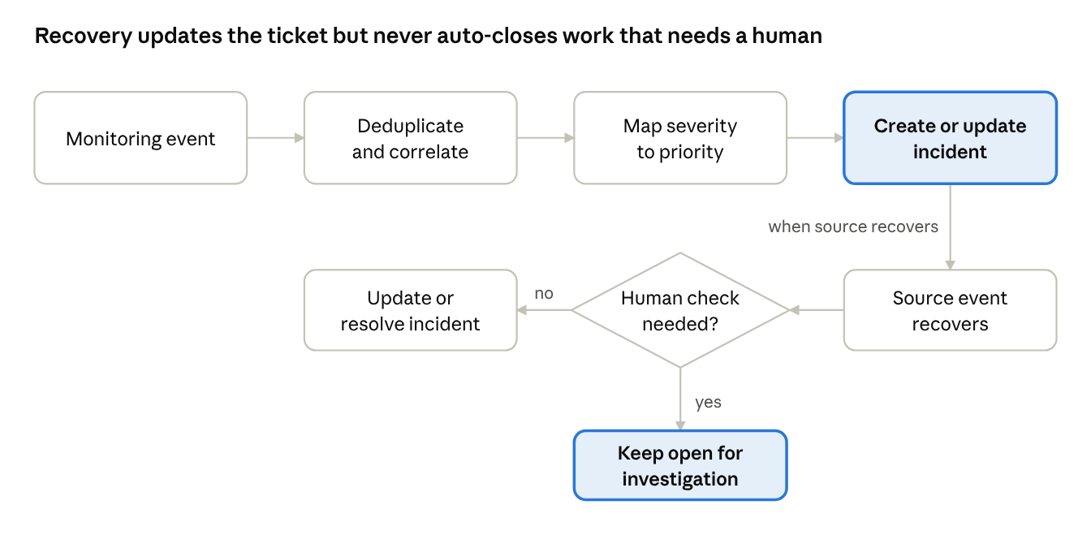
monitoring-to-ticket flow · 4 steps, recovery decision
Workflow rules decide whether a recovered event resolves its incident. Anything that needs human investigation or verification stays open.

5.8 Service-Level Agreement Management
The system shall:
- Define SLA policies by service, priority, support group, and service hours.
- Support response and resolution targets.
- Calculate due times using approved calendars and time zones.
- Support warning thresholds and breach escalation.
- Record SLA pauses only under authorized conditions.
- Produce reports on SLA achievement, breach causes, and recurring delays.

5.9 Reporting and Dashboards
The system shall provide dashboards and reports for the following areas.
Area | Reports and Dashboards
Incident Management | Open incidents by priority and age; mean time to acknowledge and resolve; major incidents and recurring failures; SLA compliance and overdue tickets.
Change Management | Changes awaiting approval; upcoming changes and scheduling conflicts; change success and failure rates; emergency changes and post-implementation reviews; unauthorized changes and rollback events.
Service Integration | Monitoring alerts converted to tickets; duplicate events and correlation effectiveness; failed integrations and synchronization delays; service availability and incident impact.
Governance and Audit | Outstanding control-related remediation actions; overdue evidence and reviews; changes requiring compliance approval; audit history and evidence completeness.

6. Non-Functional Requirements
ID | Requirement | Priority
NFR-001 | The system shall support approved cloud, on-premises, and hybrid deployment models. | M
NFR-002 | The system shall support role-based access control and least privilege. | M
NFR-003 | The system shall support MFA and integration with an approved identity provider where available. | M
NFR-004 | Data in transit shall be protected using approved TLS configurations. | M
NFR-005 | Sensitive data at rest shall be encrypted according to organizational policy and deployment capabilities. | M
NFR-006 | Audit records shall be protected against unauthorized alteration and deletion. | M
NFR-007 | The system shall provide configurable retention, backup, and recovery policies. | M
NFR-008 | The system shall support monitoring of its own availability and integration health. | M
NFR-009 | The system shall support capacity scaling based on ticket volume, monitored assets, events, and retention. | M
NFR-010 | The system shall provide documented installation, configuration, backup, restore, and upgrade procedures. | M
NFR-011 | The system shall support accessibility and usability requirements defined by the organization. | S
NFR-012 | The system shall provide audit and reporting exports in approved formats. | M

6.1 Proposed Service Targets
The following are initial targets for review, not guaranteed product performance:
Measure | Target
Monthly availability | 99.9%, subject to approved maintenance windows and measurement rules
Portal response time | 3 seconds or less for 95% of standard transactions under the agreed load
Recovery point objective (RPO) | 15 minutes, if supported by the selected architecture
Recovery time objective (RTO) | 4 hours for the primary ITSM service
Monitoring-to-ticket creation latency | 60 seconds or less for supported, successfully delivered events
The organization shall validate these targets against budget, architecture, service criticality, and recovery testing.

7. Security and Compliance Requirements
The platform shall:
- Support role-based access control and segregation of duties.
- Enforce access restrictions for incidents involving sensitive or regulated data.
- Record approval decisions, timestamps, identities, and relevant workflow changes.
- Avoid storing payment card data or other unnecessary sensitive data in ticket descriptions, comments, or attachments.
- Support evidence collection and controlled access for applicable PCI DSS and ISO 27001 requirements.
- Integrate with security monitoring and vulnerability management systems where required.
- Support defined retention, access review, and audit procedures.
- Maintain secure backups and tested restoration procedures.
- Record administrative actions and integration failures.
- Support security incident escalation and links between incident, risk, control, and remediation records.
The organization shall maintain a separate compliance mapping identifying applicable requirements, controls, owners, evidence, and assessment procedures. Software functionality alone shall not be treated as proof of compliance.

8. Cloud and On-Premises Deployment Requirements
The solution shall support the following deployment patterns, subject to verification of each selected product's capabilities and license terms.

8.1 On-Premises
- Install on organization-managed servers or virtual machines.
- Retain organizational control over system data and backups.
- Support internal identity, network, monitoring, and notification integrations.
- Continue essential local operations during internet outages where dependencies permit.

8.2 Cloud
- Support deployment in an approved cloud environment or through an approved hosted service.
- Provide access controls, encryption, backup, recovery, and monitoring.
- Support integration with cloud infrastructure and external services.
- Meet approved data residency and retention requirements.

8.3 Hybrid
- Monitor both cloud and on-premises resources through approved connectors or probes.
- Use encrypted communication and controlled network access.
- Avoid exposing internal management interfaces directly to the public internet.
- Define what happens to local monitoring and ticketing integrations when connectivity is interrupted.
The selected architecture shall document differences in features, data location, integration support, operational responsibility, and licensing between deployment options.

9. Acceptance Criteria
The solution shall not be accepted for production until the following tests pass.
ID | Acceptance Test | Expected Result
AC-001 | Submit an incident through the portal. | A unique incident is created with the required fields.
AC-002 | Trigger a configured monitoring event. | A correctly prioritized incident is created or updated without unwanted duplicates.
AC-003 | Escalate an overdue incident. | The configured escalation and notification occur.
AC-004 | Submit a normal change. | The change cannot proceed to implementation before required approvals.
AC-005 | Submit an emergency change. | The emergency workflow records authorization and requires retrospective review.
AC-006 | Implement a failed change in a test environment. | Failure and rollback evidence are recorded and linked to an incident when required.
AC-007 | Link a ticket to a service or configuration item. | The relationship is visible and traceable.
AC-008 | Disable an integration endpoint in a controlled test. | Failure is logged and retry or recovery behavior follows policy.
AC-009 | Attempt unauthorized access to an administrative function. | Access is denied and relevant security events are recorded.
AC-010 | Restore the platform from backup. | Recovery meets the approved RPO and RTO.
AC-011 | Review an incident and change audit trail. | Authorized reviewers can reconstruct key actions, approvals, and timestamps.
AC-012 | Export required audit and compliance records. | The export contains the agreed records and access protections.

10. Implementation Phases
Phase | Focus | Key Activities
Phase 1 | Requirements and design | Confirm stakeholders, services, roles, priorities, SLAs, and approval rules. Define the CMDB model, integrations, security requirements, and deployment topology.
Phase 2 | Core ITSM | Configure ticketing, incident management, change management, and service requests. Configure categories, assignment groups, notification rules, and dashboards.
Phase 3 | Integrations | Integrate monitoring, CMDB, identity, email, and approved collaboration tools. Configure event deduplication, incident creation, recovery updates, and synchronization monitoring.
Phase 4 | Governance and security | Integrate GRC and security monitoring where required. Establish control evidence, audit history, access reviews, and remediation workflows.
Phase 5 | Testing and production rollout | Execute acceptance, security, integration, backup, and recovery tests. Train users, approve operating procedures, and establish service ownership.

11. Deliverables
The implementation project shall deliver:
- Approved requirements specification.
- Solution architecture and deployment design.
- Incident and change workflow diagrams.
- Role and permission matrix.
- SLA and priority matrix.
- Integration specifications and API documentation.
- CMDB data model and service relationship design.
- Security and compliance control mapping.
- Test plan and acceptance evidence.
- Backup, recovery, and disaster recovery procedures.
- User guides and administrator documentation.
- Production-readiness checklist and handover report.

12. Assumptions and Decisions Required
Before implementation, the project owner shall approve:
- Selected products and supported deployment editions.
- Hosting model and data residency requirements.
- Incident priority and SLA definitions.
- Change categories and authorization matrix.
- Emergency change procedure.
- Service catalog and CMDB ownership.
- Monitoring and security event sources.
- Identity provider and notification channels.
- Audit retention and evidence requirements.
- Availability, backup, RPO, and RTO targets.
- Applicable PCI DSS and ISO 27001 scope.
- Licensing, support, staffing, and implementation budget.

Appendix A. Glossary
Term | Meaning
ITSM | IT Service Management: managing IT services from request to resolution.
ITIL | A widely used framework of IT service management practices.
CMDB | Configuration Management Database: records IT assets and how they relate to each other.
CI | Configuration item: a single tracked component, such as a server, application, or device.
SLA | Service-level agreement: agreed response and resolution targets.
Major incident | An incident that needs coordinated response (INC-009).
Problem record | A record linking recurring incidents to their underlying cause (INC-015).
Standard change | A pre-authorized change that follows a documented model (CHG-002).
Normal change | A change that needs documented risk assessment and approval before implementation (CHG-003).
Emergency change | A change with expedited authorization and a retrospective review (CHG-004).
CAB | Change Advisory Board: reviews changes according to risk and policy.
Post-implementation review | A review required for failed, emergency, and other high-risk changes (CHG-015).
Deduplication | Merging repeated monitoring events so they do not create duplicate tickets (INT-003).
Rollback | Returning a failed change to its previous state using the rollback plan.
RPO | Recovery point objective: the most data loss, measured in time, that is acceptable.
RTO | Recovery time objective: the longest acceptable time to restore the service.
GRC | Governance, risk, and compliance.
MFA | Multi-factor authentication.
PCI DSS | Payment Card Industry Data Security Standard.
ISO 27001 | International standard for information security management.

Appendix B. Requirement Reference
Prefix | Area | Section | Total | Mandatory | Should have
INC | Incident management | 5.1 | 15 | 13 | 2
CHG | Change management | 5.3 | 17 | 16 | 1
TKT | Ticketing and service requests | 5.5 | 12 | 10 | 2
INT | Service integration and CMDB | 5.6 | 12 | 11 | 1
NFR | Non-functional requirements | 6 | 12 | 11 | 1
Total |  |  | 68 | 61 | 7
The 12 acceptance tests (AC-001 to AC-012) in Section 9 verify these requirements before production release.

Appendix C. Acceptance Test Traceability
The table shows the main requirements each acceptance test verifies.
Test | Main requirements verified
AC-001 | INC-001, INC-003
AC-002 | INC-002, INT-002, INT-003
AC-003 | INC-007, INC-008
AC-004 | CHG-003, CHG-009
AC-005 | CHG-004, CHG-015
AC-006 | CHG-014
AC-007 | INC-011, INT-004
AC-008 | INT-009
AC-009 | NFR-002, Section 7 item 9
AC-010 | NFR-007, Section 6.1 (RPO, RTO)
AC-011 | TKT-009, CHG-016, NFR-006
AC-012 | NFR-012

